**DAILY ONLINE ACTIVITIES SUMMARY**

|  |  |  |  |  |  |  |  |
| --- | --- | --- | --- | --- | --- | --- | --- |
| **Date:** | **12/07/2020** | | | | **Name:** | **Anusha. K** | |
| **Sem & Sec** | **4th SEM 'A' Section** | | | | **USN:** | **4AL18CS009** | |
| **Online Test Summary** | | | | | | | |
| **Subject** | | **No test** | | | | | |
| **Max. Marks** | | **-** | | **Score** | | **-** | |
| **Certification Course Summary** | | | | | | | |
| **Course** | **Data visualization using tabulae** | | | | | | |
| **Certificate Provider** | | | **greatlearning academy** | **Duration** | | | **11.2 hours** |
| **Coding Challenges** | | | | | | | |
| **Problem statement: Write a Java program for Reversal algorithm for array rotation by 3.** | | | | | | | |
| **Status: completed** | | | | | | | |
| **Uploaded the report in Github** | | | | **yes** | | | |
| **If yes Repository name** | | | | [**https://github.com/anusha20219/Lockdown-coding**](https://github.com/anusha20219/Lockdown-coding) | | | |
| **Uploaded the report in slack** | | | | **yes** | | | |

ONLINE TEST DETAILS: No test

CERTIFICATION COURSE DETAILS: Today I studied about topic data visualization using tabulae.

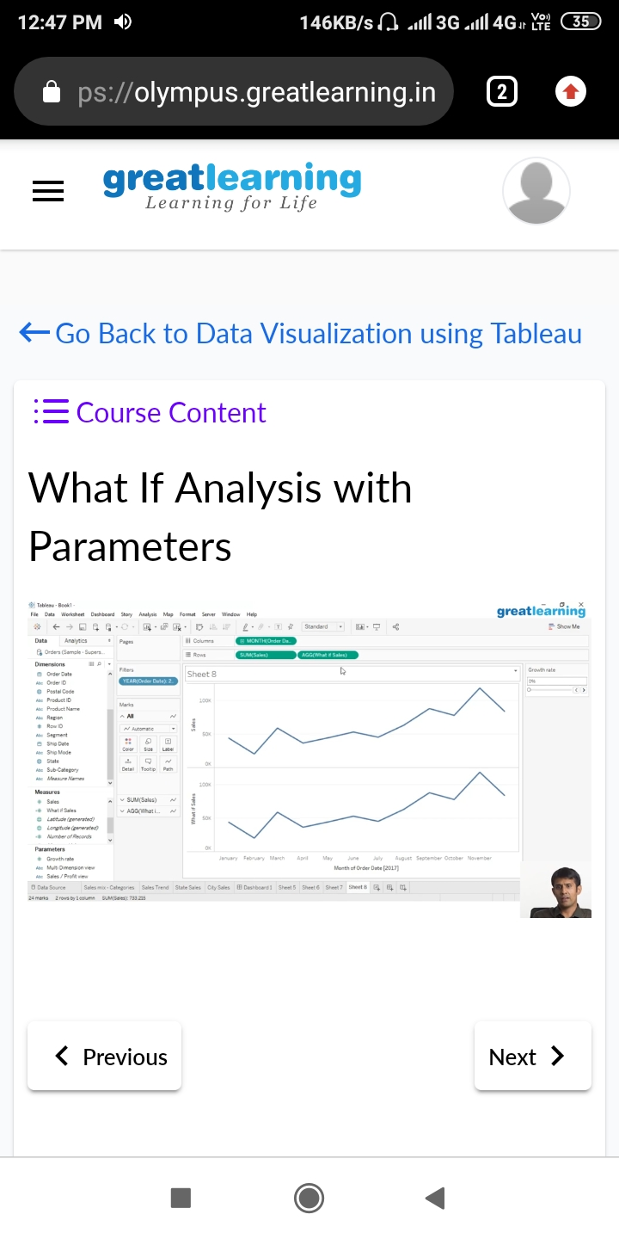

**CODING CHALLENGES DETAILS**:

Problem statement : Write a Java program for Reversal algorithm for array rotation by 3.

